Name: Kamal Agrahari Lab: DevOps

ID: VU4F2223028 Class: TE/A

**Experiment no. 9**

**Aim** : Running selenium test cases to test web-based UI components.

**Theory** :

Running Selenium test cases to test web-based UI components in Python involves several steps. Below, I'll outline a basic setup and provide an example to help you get started.

**1. Install Required Packages**

First, ensure you have Python installed on your machine. Then, install Selenium using pip:

pip install selenium

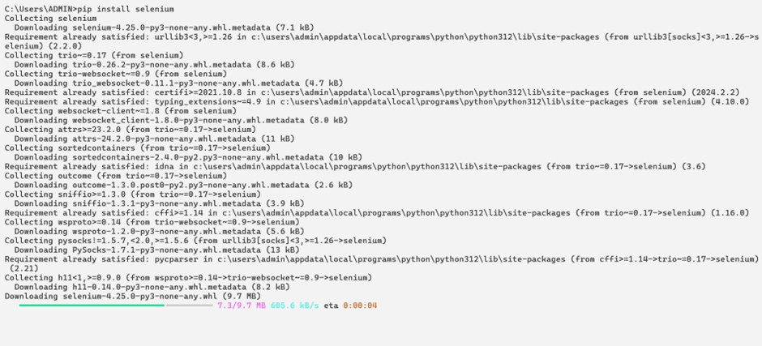

**2. Set Up a WebDriver**

Selenium requires a WebDriver to interface with the browser. For example, if you're using Chrome, you'll need ChromeDriver. Make sure you download the driver that matches your installed Chrome version from here.

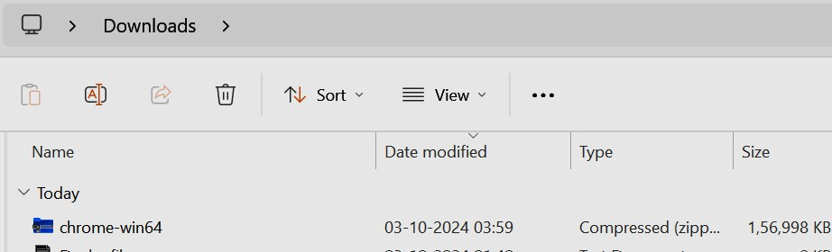

**3. Example Test Case**

Here’s a basic example of a Selenium test case that opens a web page, interacts with elements, and verifies the page title.

Example Code-

***Test.py***

from selenium import webdriver

from selenium.webdriver.common.by import By

from selenium.webdriver.common.keys import Keys from selenium.webdriver.chrome.service import Service import time

# Set the path to your WebDriver (e.g., ChromeDriver)

driver_path='C:\\Users\\ADMIN\\chromedriver-win64\\chromedriver.exe'

#yourChromedriverPath service = Service(driver_path)

driver = webdriver.Chrome(service=service)

try:

# Open a web page

driver.get('http://google.com') # Replace with your target URL

# Wait for the page to load

time.sleep(2) # Implicit wait; you can also use WebDriverWait for better practices

# Interact with elements

search_box = driver.find_element(By.NAME, 'q') # Example element search_box.send_keys('Selenium WebDriver' + Keys.RETURN)

# Wait for results to load time.sleep(2)

# Verify the title

assert 'Selenium WebDriver' in driver.title

print("Test Passed: Page title is correct.")

except Exception as e:

print(f"Test Failed: {e}")

finally:

# Close the browser driver.quit()

**4. Run Your Test Case**

1. Save the script in a .py file (e.g., test_script.py).

2. Run it using Python:

$ python test_script.py

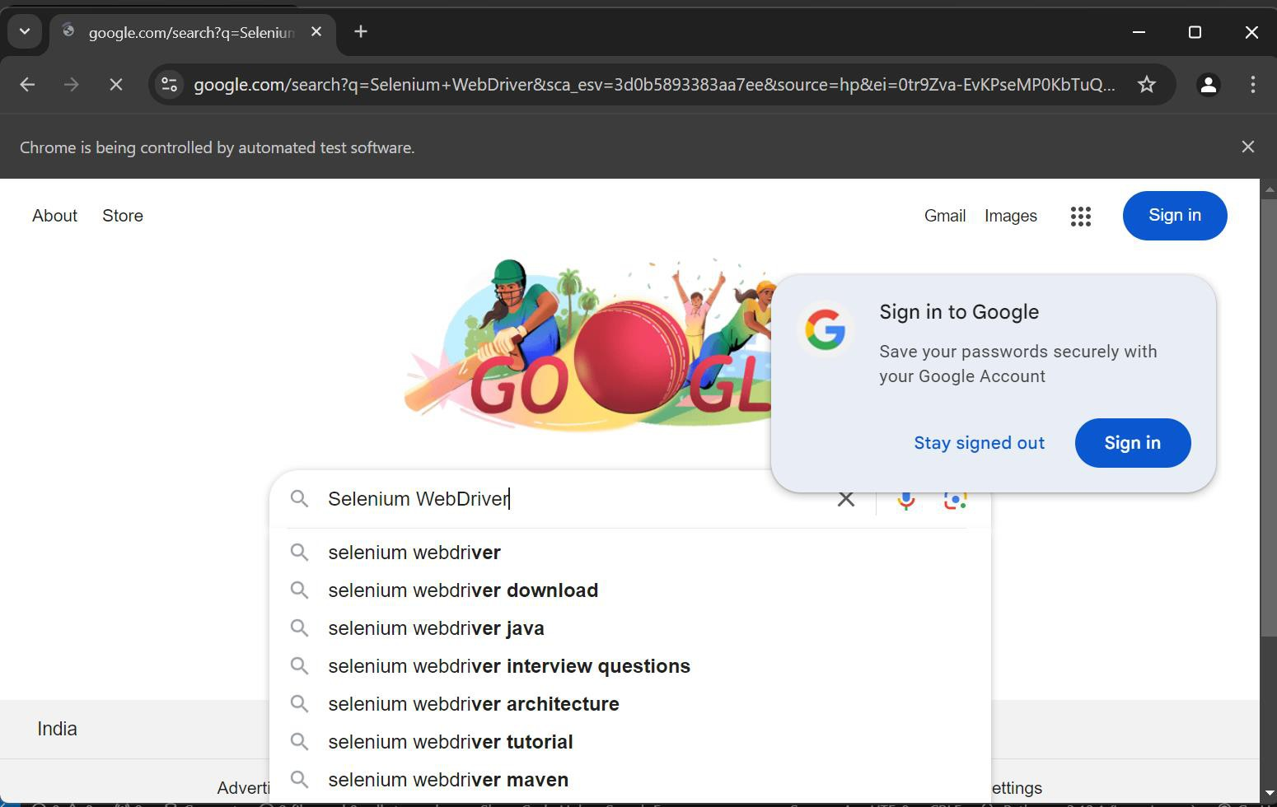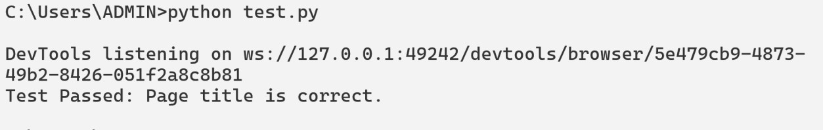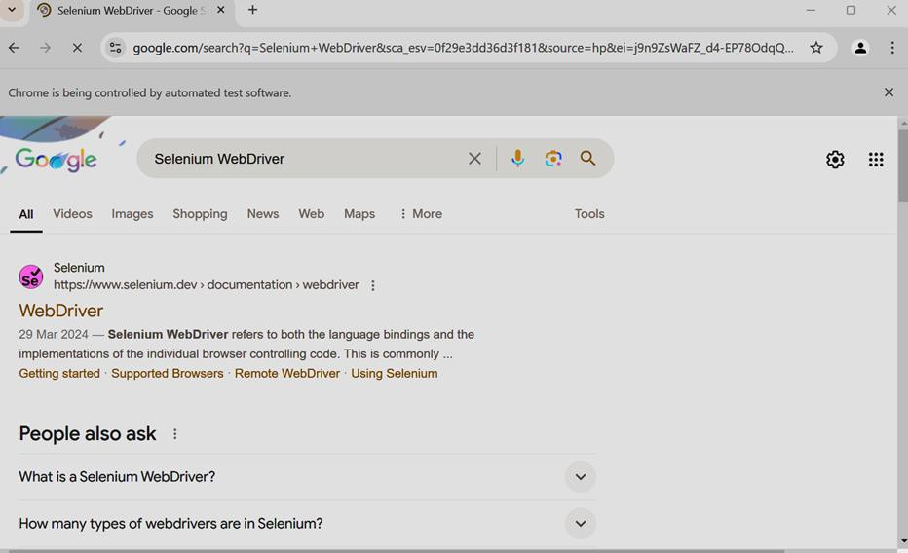

Conclusion: Hence we have performed selenium test on web-based UI components.